**Visual Studio Code Installation Documentation**

Previous

**Step 1:**  Download Visual Studio Code from – [https://code.visualstudio.com](https://code.visualstudio.com/)

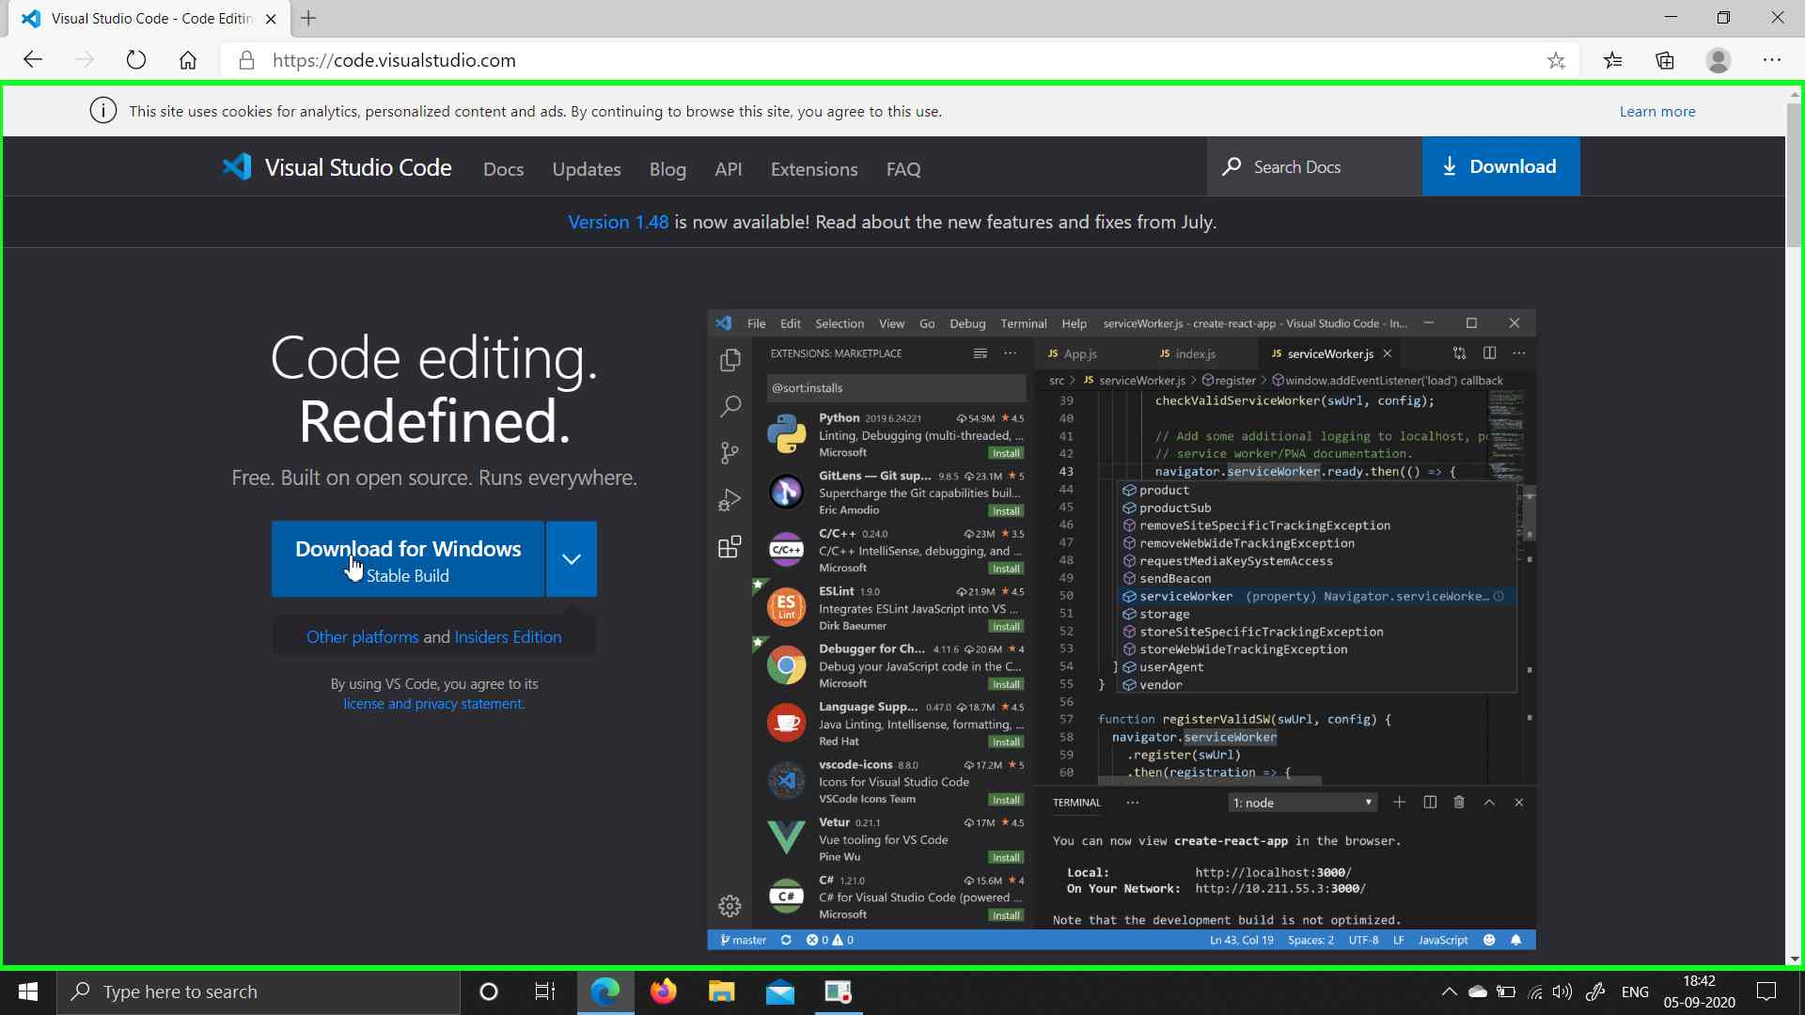

**Step 2:** Open setup file

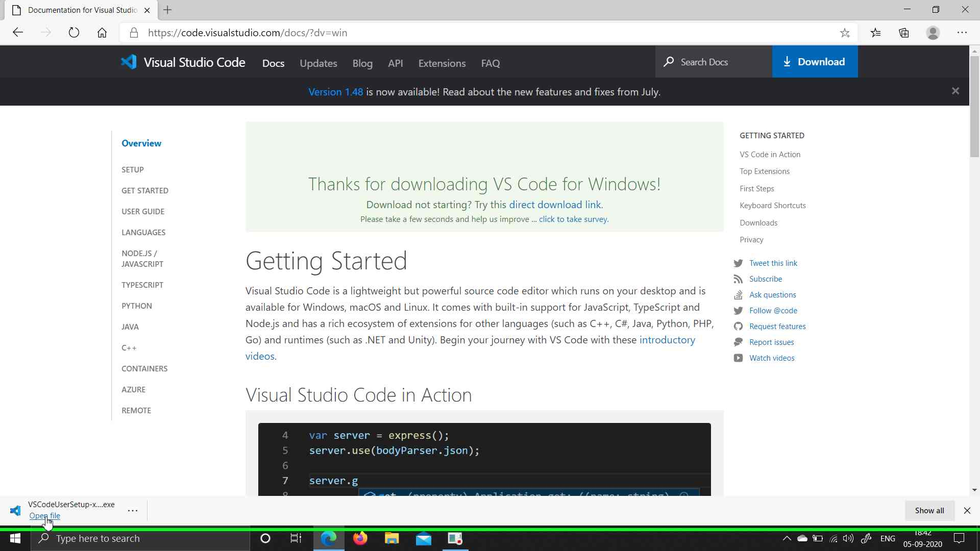

**Step 3:**  Select "I accept the agreement (radio button)"

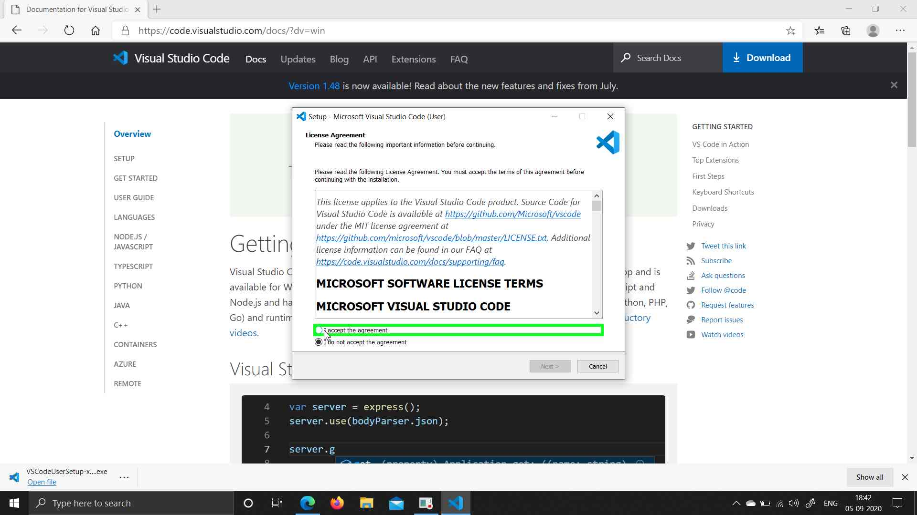**Step 4:** Select Next button on the following screens

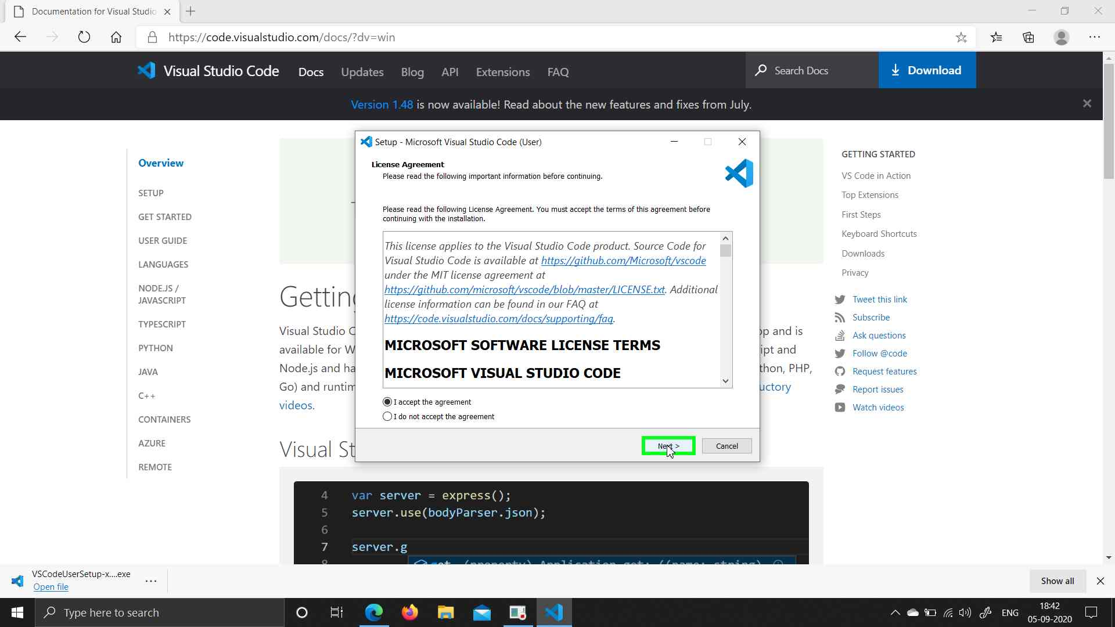

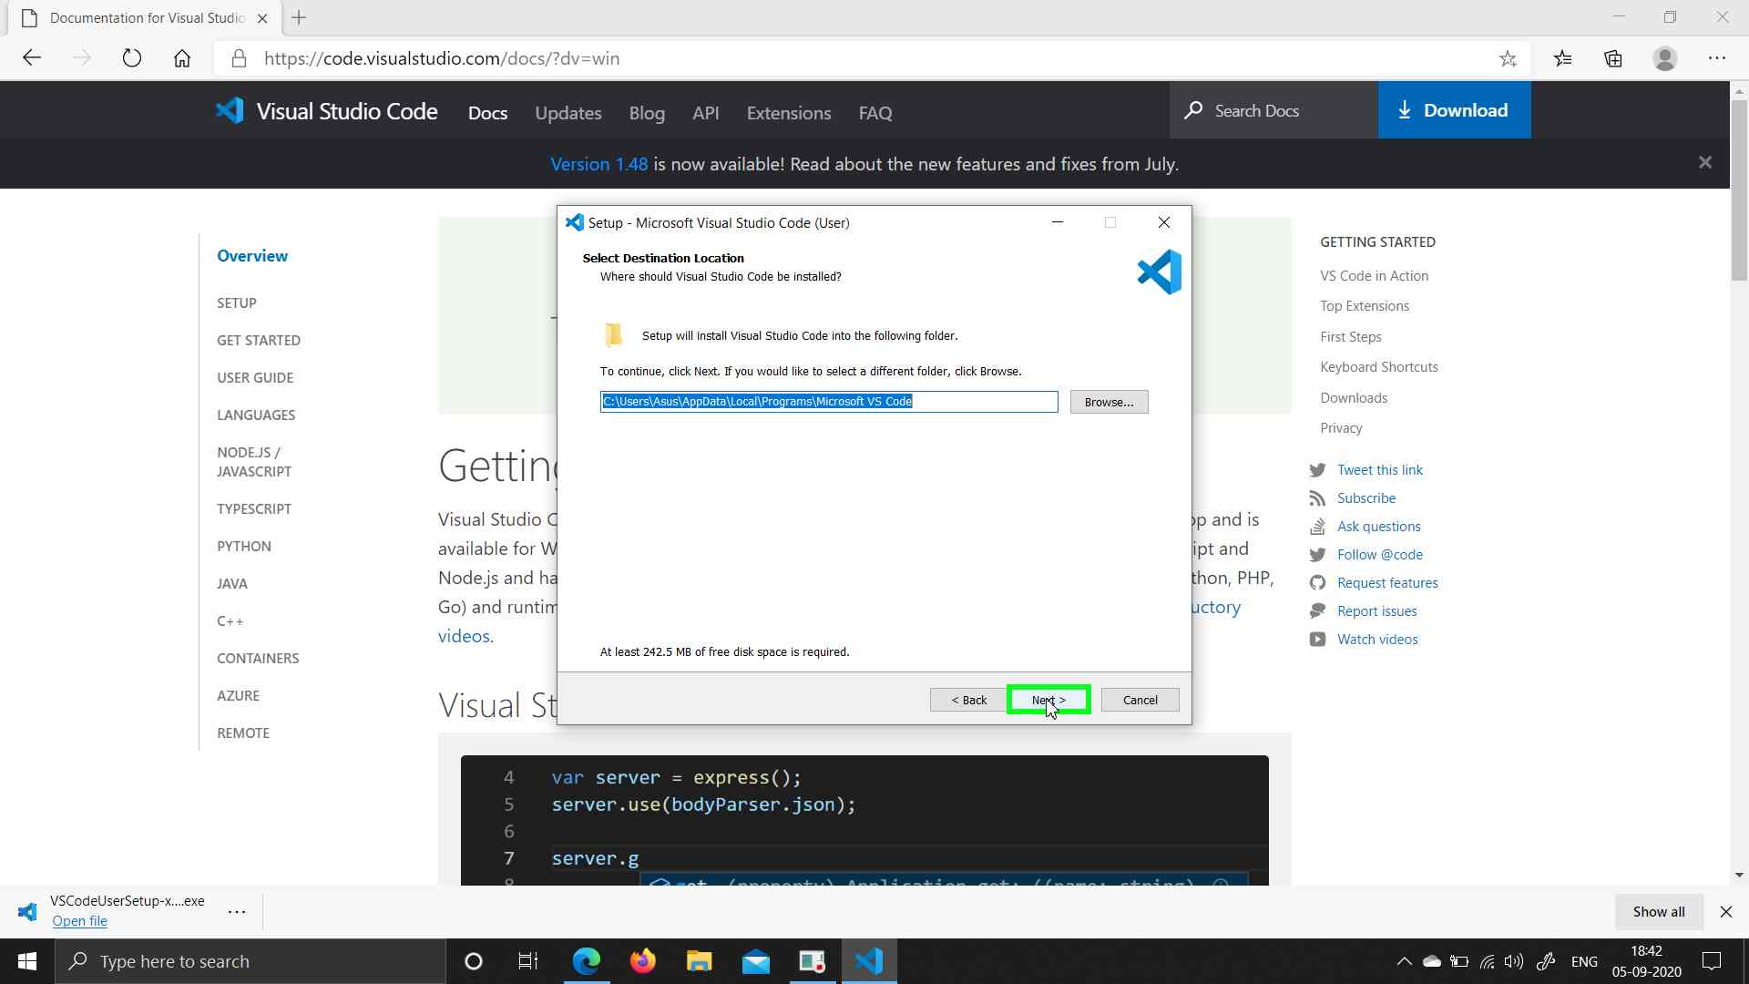

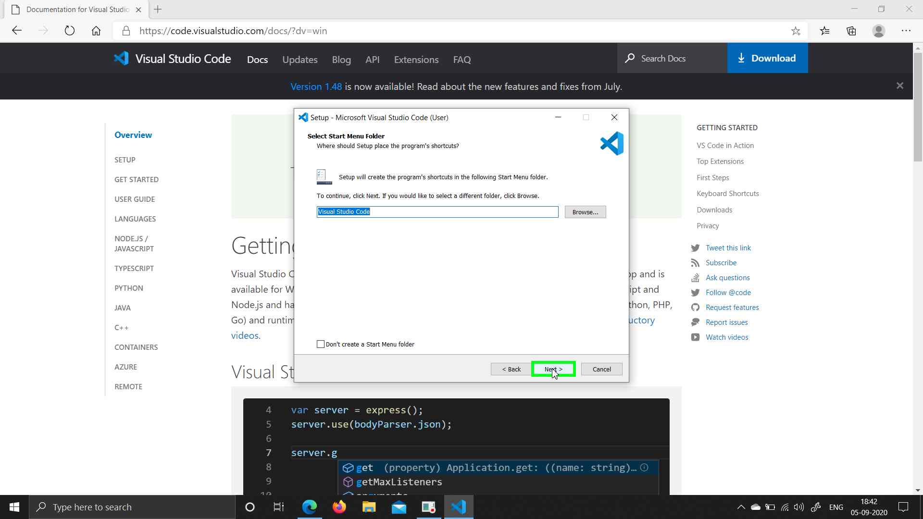

**Step 5:** Select "Register Code as an editor for supported file types (check box)", "Add 'Open with Code' action to Windows Explorer directory context menu (check box)", "Add 'Open with Code' action to Windows Explorer file context menu (check box)"

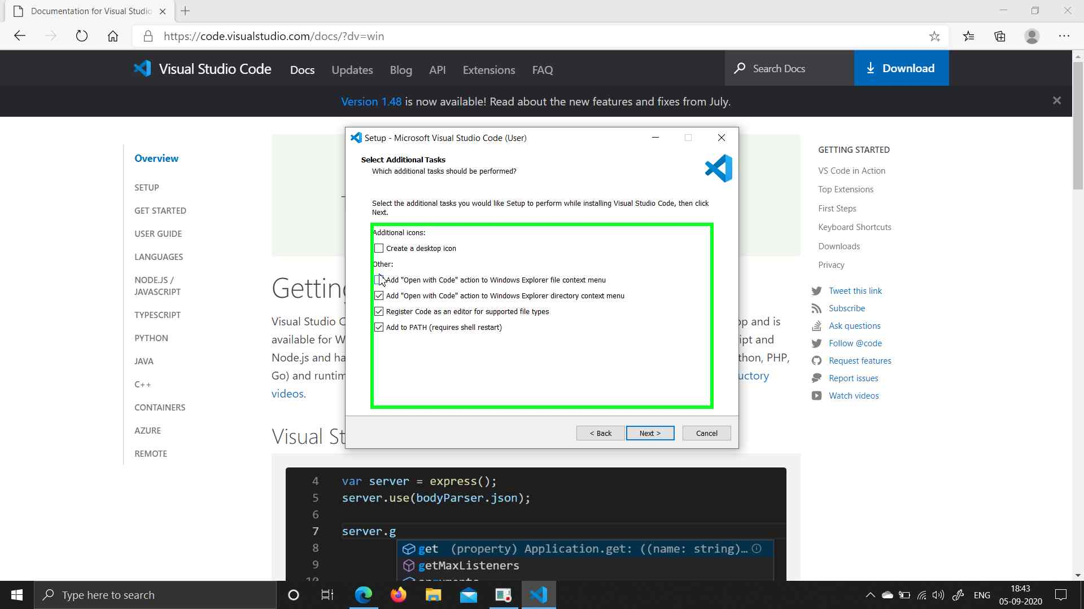

**Step 6:** Select Next button on the following screen

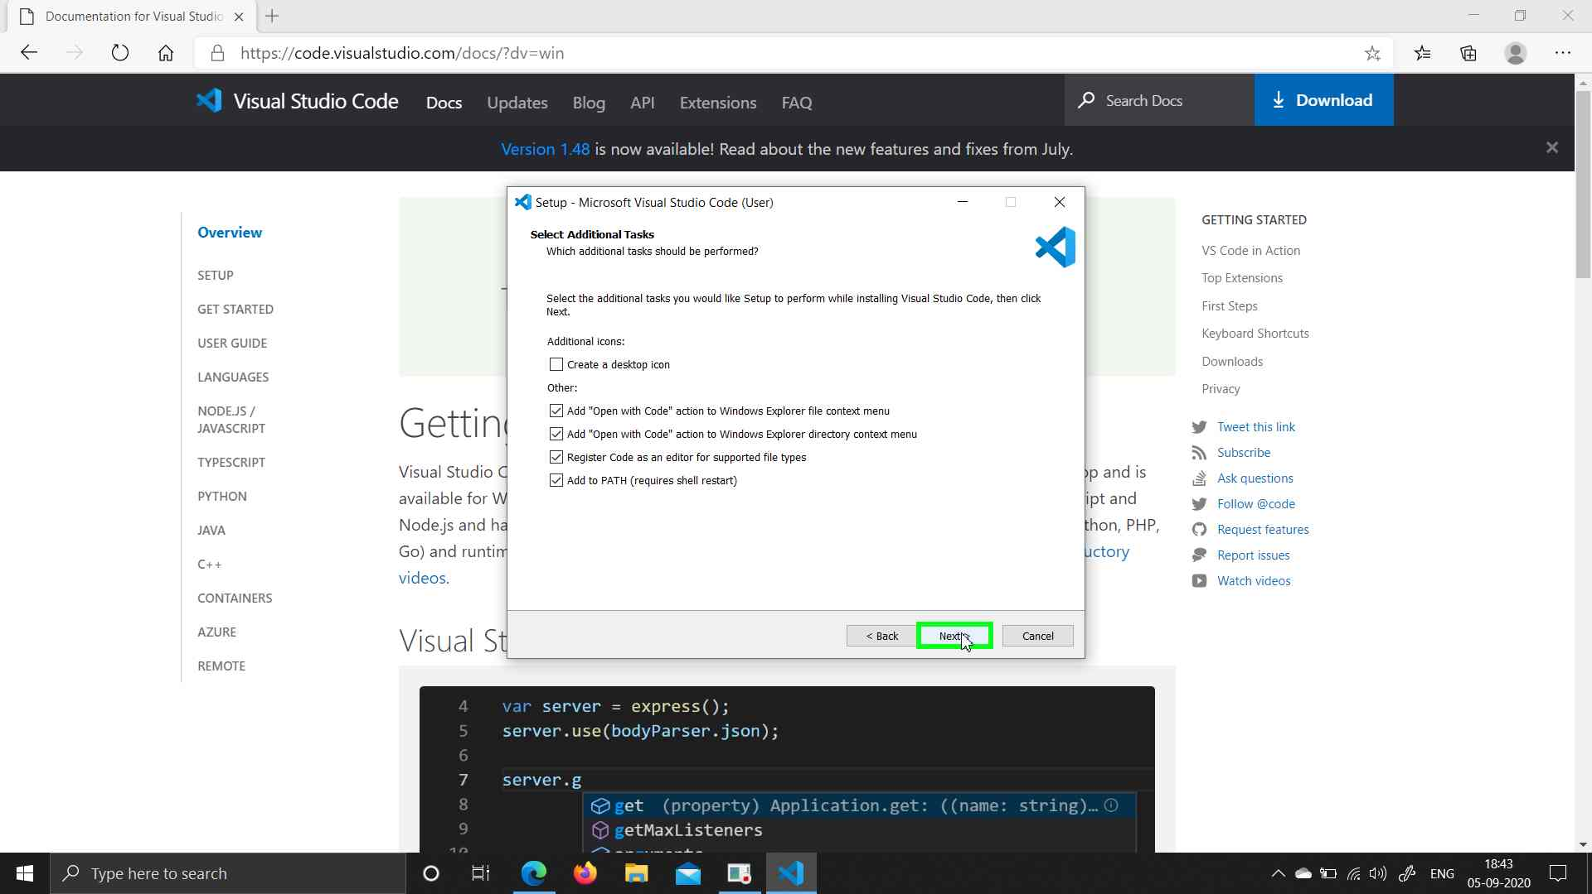

**Step 7:** Select Install button on the following screen

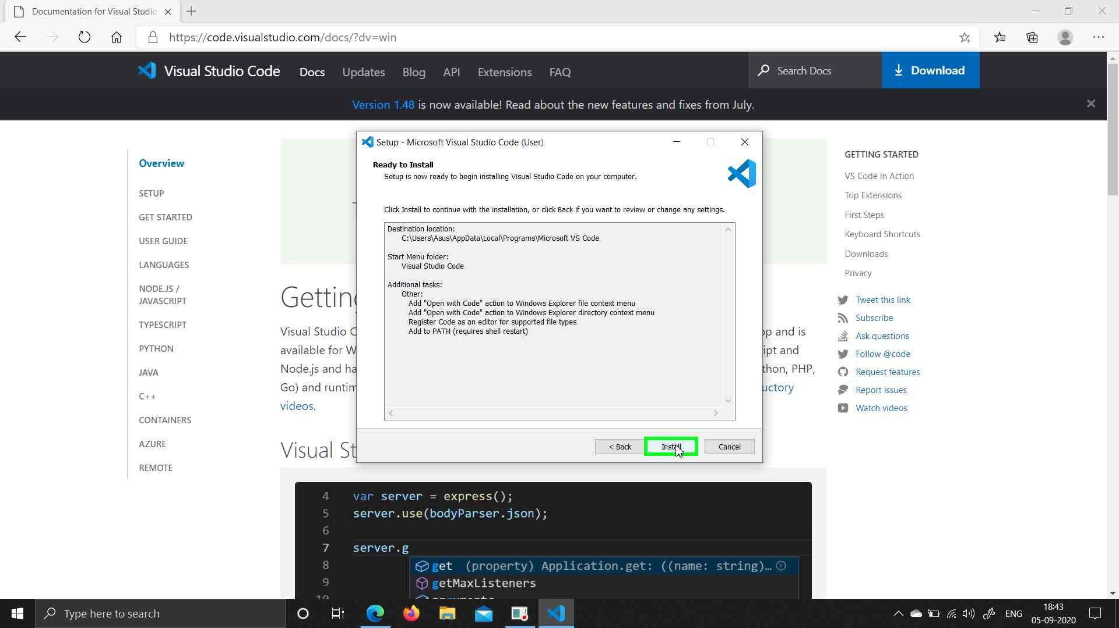**Step 8:** Select Finish button on the following screen

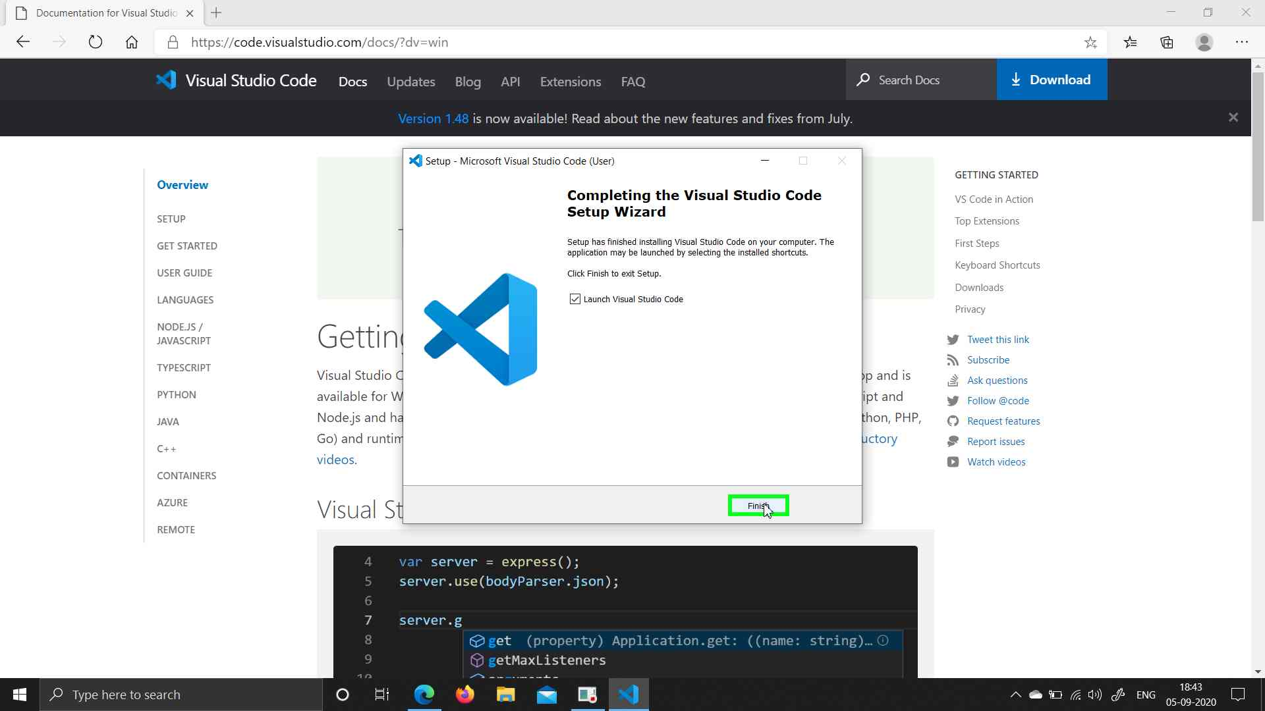

**Install Flutter Extension**

**Step 1:** Click on Extensions

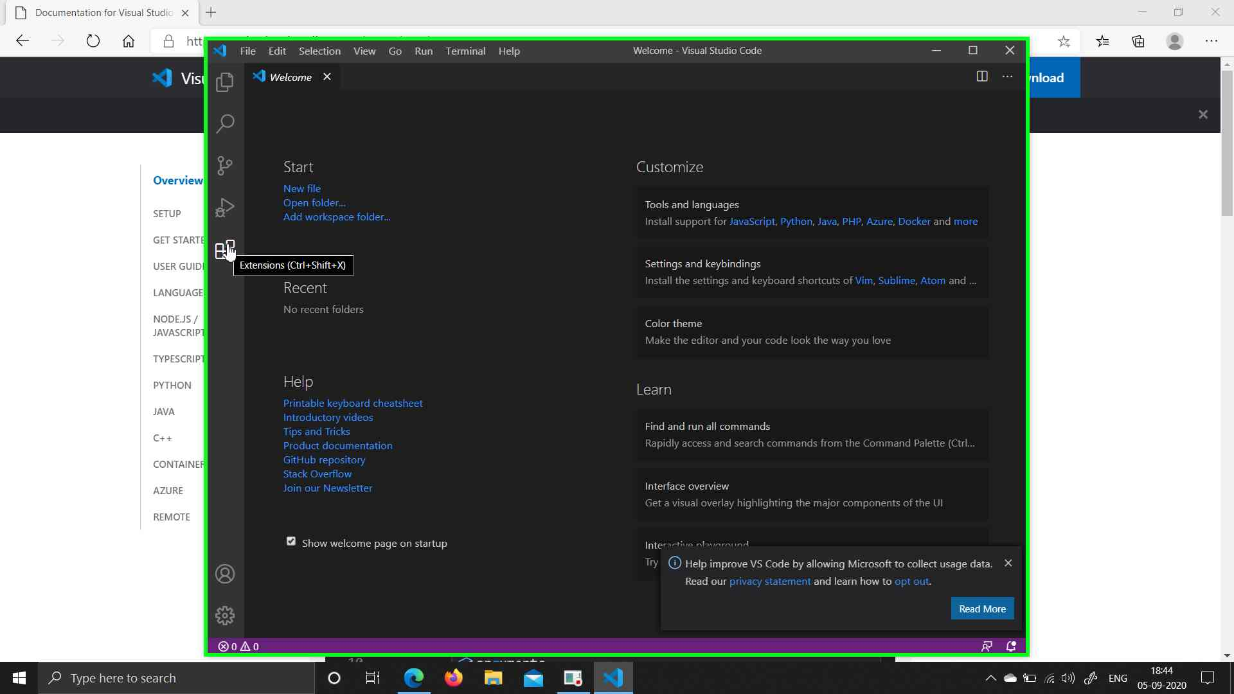

**Step 2:** Type Flutter in search bar.

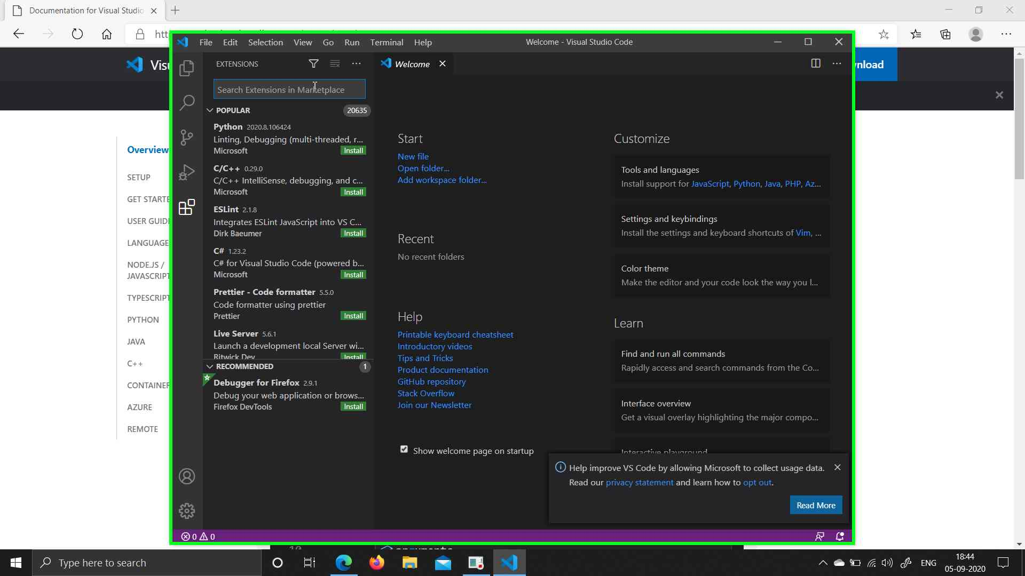

**Step 3:** Select Flutter

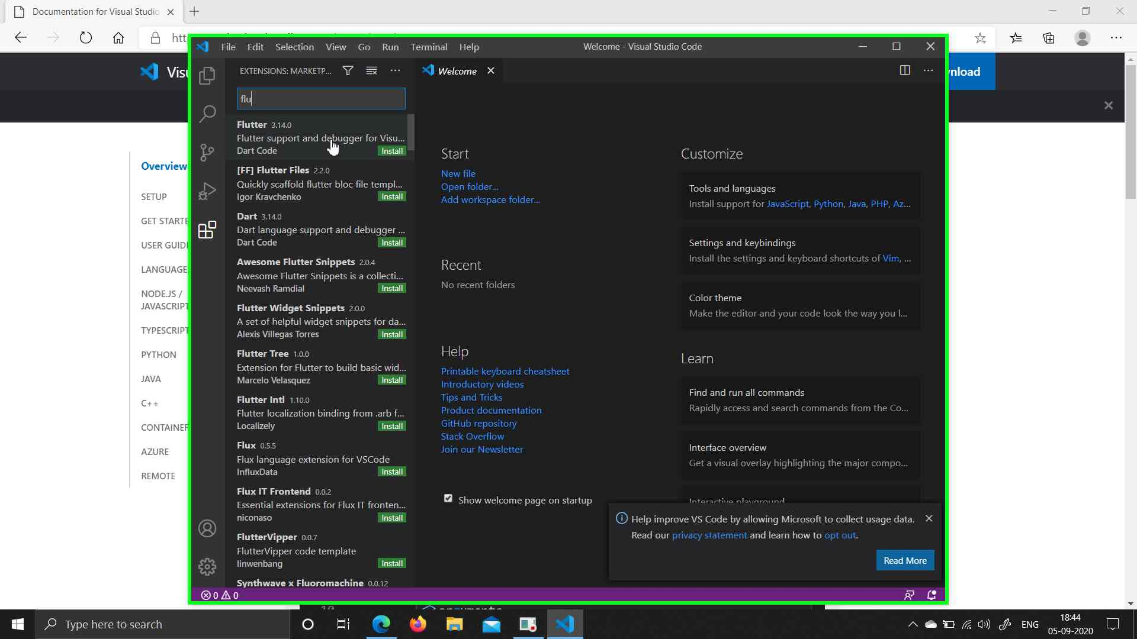**Step 4:** Click on Install

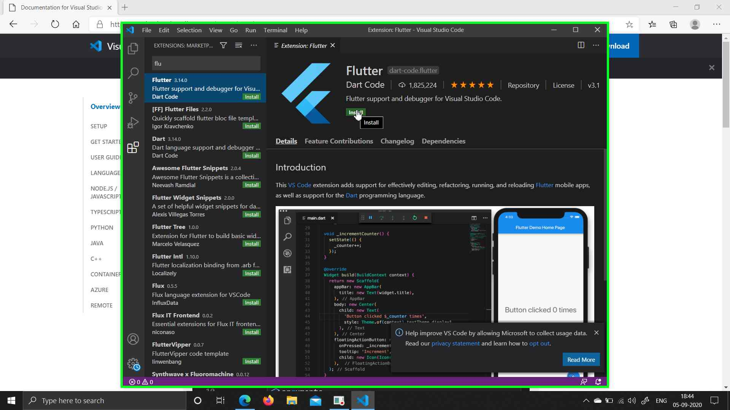 Next